**Dokumentasi (*screenshot)* Q2 - *Team Challenge*:**

1. *Kubectl get nodes*

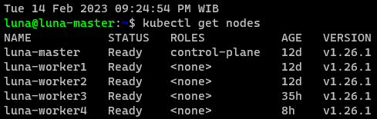

1. *Kubecetl describe: luna-worker1*

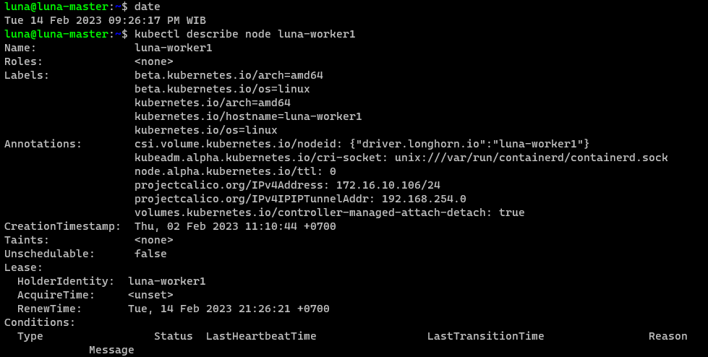

1. *Kubectl get pod -A*

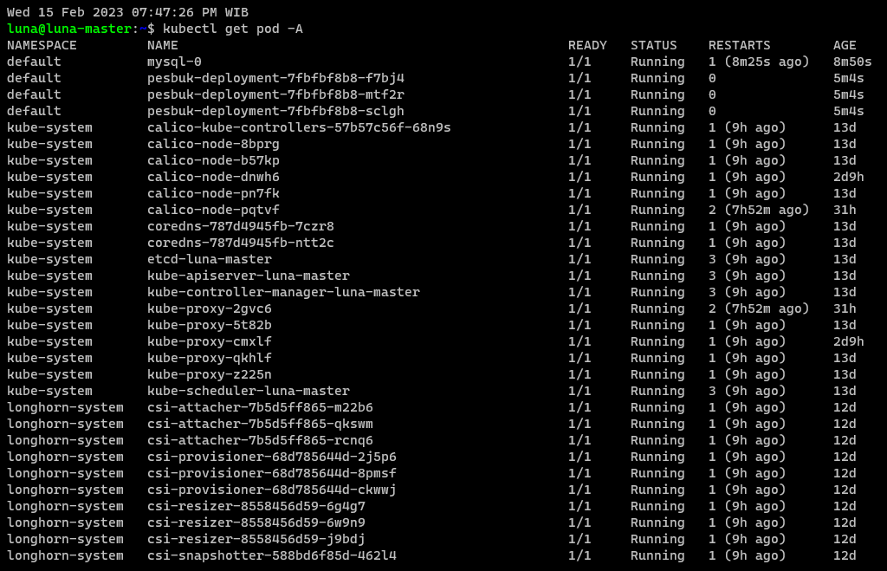

1. *Kubectl get svc -A*

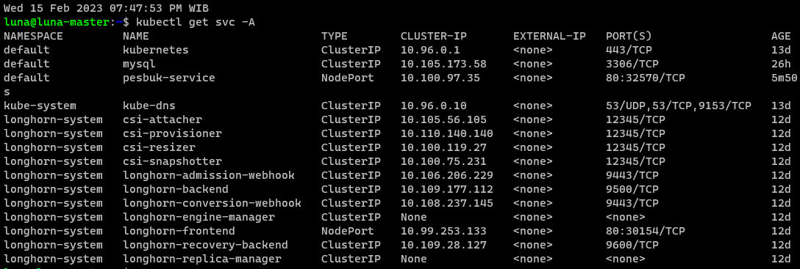

1. *Kubectl get secret*

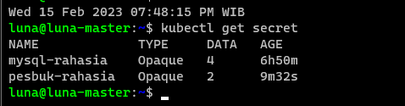

1. *Kubectl get configmap*

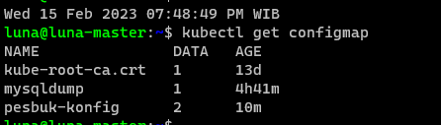

1. *Kubectl pv*

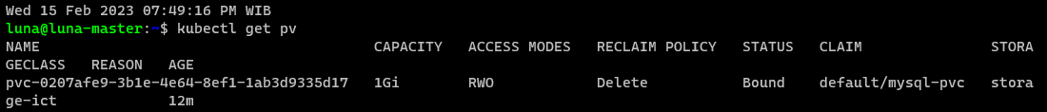

1. *Kubectl get pvc*

